**SMALL TALK**

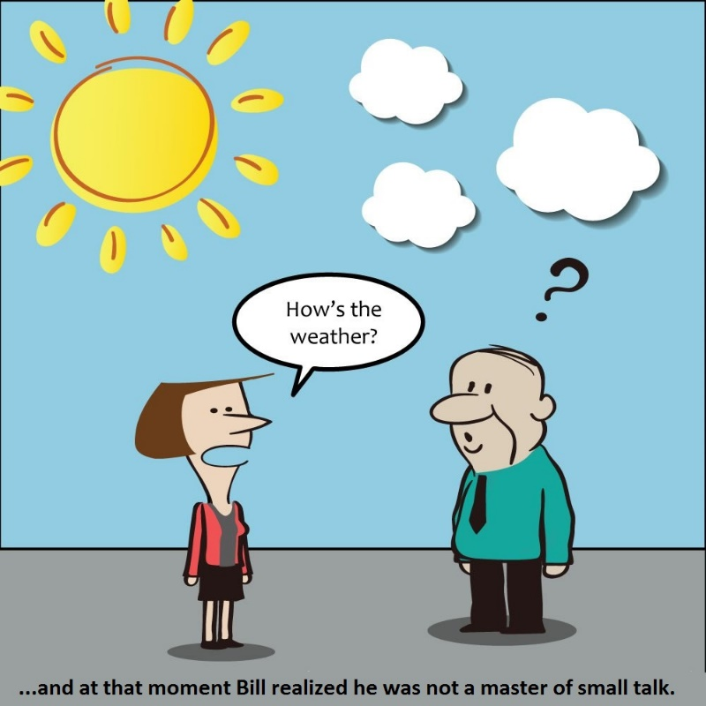

***1****.* (a) *Look at the cartoon. What would you say in answer to the woman’s question? What would you say next?*

*(b) Discuss the questions below with a partner:*

* *What is small talk? Do you consider yourself good at it? Why/ why not?*
* *When was the last time you made small talk? Who did you talk with?*
* *Do you think it’s necessary to make small talk with your customer /other teams during skype meetings? Why/why not? If yes, in what situations?*

***2a.*** *What are some good small talk topics, in your opinion? What topics are best avoided?*

***b.*** *Watch the extracts from the videos and identify small talk topics. Are the hosts interested in what the guests are saying?*

[Video 1](https://youtu.be/B1GFzd7KYfI?t=27s) (0:27 to 0:50) Topic: __________________________________

[Video 2](https://epam-my.sharepoint.com/:v:/p/olga_lifshits/EaB5n-sFEwZAteo1ob1h4HIBFft6n3XDlI047Iowzxchlg?e=akAgZ7) (26:19 to 26:55) Topic: __________________________________

[Video 3](https://youtu.be/IIjV1EITyeY?t=16s) (0:20 to 0:41) Topic: __________________________________

[Video 4](https://youtu.be/fR1J7_fUGvQ?t=25s) (0:25 to 1:02) Topic: __________________________________

***3.*** *Watch the videos 1-4 again and fill in the gaps with what you hear.*

[Video 1](https://youtu.be/B1GFzd7KYfI?t=27s) (0:27 to 0:50)

JW: (1) ___________________________, Adrian?

AH: (2) _______________. Nice to be here.

JW: Thank you very much for joining today. (3) ________________out in Chicago?

AH: No.

JW: Spring has started.

AH: Not snowy. It appears to be clear outside today.

JW: (4) _____. (5)_____ I understand you've been working on a new project for a little while. …

[Video 2](https://epam-my.sharepoint.com/:v:/p/olga_lifshits/EaB5n-sFEwZAteo1ob1h4HIBFft6n3XDlI047Iowzxchlg?e=akAgZ7) (26:19 to 6:55)

A: Hey, how are you?

IN: (1)__________. How are you?

RM: (2)___________. Thank you for joining us. (3) _________ in, I'm gonna go ahead and presume you’re in Italy at the moment?

A: Yes, I am in Italy. [Laughter] It's 10 after 9 right now.

IN: That's not so bad.

RM: That's a reasonable, that's a reasonable time.

IN: So (4)________________, Andrea?

A: Sorry?

IN: (5) __________________? What city?

A: I am in Jesolo which is a city near Venice. It's about 30 kilometers from Venice.

IN: Oh, quite close then.

RM: (6) ____. (7) ___, yeah, so you developed FastBooking and….

[Video 3](https://youtu.be/IIjV1EITyeY?t=16s) (0:20 to 0:41)

JW: Hello everyone. My name is Jarek Wilkiewicz. Welcome to YouTube Developers Live. We have an exciting show for you today. In the studio, let me introduce our guests. Hannah Eaves from Link TV. How are you doing, Hannah?

HE: (1) ____________, thank you.

JW: (2) ___________________?

HE: It was awesome.

JW: (3) _____________________?

HE: I did. I went to Greece and Turkey and I'm feeling very mellow and relaxed.

JW: Great frame of mind for this show.

[Video 4](https://youtu.be/fR1J7_fUGvQ?t=25s) (0:25 to 1:02)

JJB: Jarek, how are you doing today?

JW: (1)________________________. How are you?

JJB: (2)________________.

JW: So you’ve been quite busy lately. I haven't seen you around. (3)_________________________, JJ?

JJB: Well, I was talking to my wife. And she says, you're not a real developer. You just play one on TV. And so I figured I should do something about that. And so I started releasing the backlog of Open Source projects that I have.

JW: (4) _________ . (5) _____________. What have you released lately?

JJB: So I released three projects.

***4.*** *Add the gapped phrases from the script to the table below:*

|  |  |
| --- | --- |
| ***Function*** | ***Expressions from the videos*** |
| *Saying ‘How are you?* |  |
| *Replying to ‘How are you?’* |  |
| *Small talk questions* |  |
| *Showing that you’re interested in the answer* |  |
| *Showing that you’re going to end small talk (and move to the next topic).* |  |

***5.*** *Work with a partner and practice making small talk. Use the flow charts below*

***Conversation 1: location and time***

***Student B****, respond and greet your partner*

***Student A****, greet your partner*

***Student A****, ask where student B is located*

***Student B****, respond*

***Student A****, show interest and ask about the current time in that location*

***Student B****, respond*

***Student A****, show interest and move on to a work-related question*

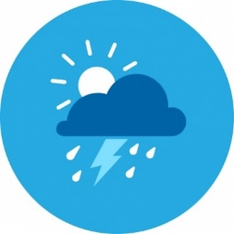***Conversation 2: the weather***

***Student A****, greet your partner*

***Student B****, respond and greet your partner*

***Student A****, ask about the weather in your partner’s location*

***Student B****, respond*

***Student A****, show interest and move on to a work-related question*

***Conversation 3: last vacation***

***Student B****, respond and greet your partner*

***Student A****, greet your partner*

***Student A****, ask about Student B’s last vacation*

***Student A****, show interest and ask a follow-up question*

***Student B****, respond*

***Student A****, show interest and move on to work*

***Student B****, respond*

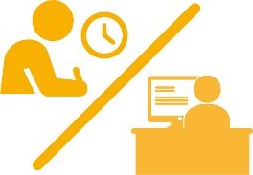***Conversation 4: recent activity***

***Student B****, respond and greet your partner*

***Student A****, greet your partner*

***Student A****, ask about Student B’s recent activity*

***Student B****, respond*

***Student B****, respond*

***Student A****, show interest and move on to work*

***Student A****, show interest and ask for more*

***6.*** *Complete the gaps with informal greetings on the left and replies to them on the right.*

|  |  |
| --- | --- |
| **Speaker 1** | **Speaker 2** |
| * **_____’_** **up**? | * **Nothing m____,** actually. |
| * **How’s it** **g__________?** | * **F____ / p______ w _____** thanks. Having a good week. |
| * **What’s ___w (with you)?** | * **Not __ l___,** actually. Looking forward to my vacation. |

*Now add them to the table in (4)*

***7.*** *Put the words in the correct order to make small talk questions.*

(1a) your plans / what / upcoming weekend / for / are / the?

*________________________________________________________________________*

(1b) doing / you / anything interesting / are / weekend / at /the?

*________________________________________________________________________*

you / do / anything interesting / did / weekend / at / the

*________________________________________________________________________*

(2a) like / the / what’s / today / weather?

*________________________________________________________________________*

(2b) in Stockholm / the / how’s / weather?

*________________________________________________________________________*

(3a) going / your day / how’s?

*________________________________________________________________________*

(3b) far / your day / how’s / been / so?

*________________________________________________________________________*

***8.*** *Work with a partner. Student A, pick a question from one of the pairs of questions above and ask your partner. Student B, reply and ask your partner the second question from the pair.*

***Student A****, greet your partner*

***Student B****, respond and greet your partner*

***Student A****, respond and ask a question*

*from one of the pairs of questions*

***Student B****, respond. Ask the other question from the pair*

***Student A****, respond*

***Student A****, signal the end of small talk*

***Student B****, show interest. Keep the conversation going for at least 1 min*